Purpose: Day 6 Classwork and Assignment
Date: 29/12/2025
Author: Vinayak Majhi
ID: 58618
Batch ID: 25SUB4505 - DATACOM+5G

ClassWork

Q.1 Create a class which has a pointer as a data member (dynamic memory).
Pass object by value to a function.
Track how many times copy constructor is called.
Explain shallow vs deep copy impact.
// Purpose: Demonstrate copy constructor call count and shallow vs deep copy
// Date: 29/12/2025
// Author: Vinayak Majhi
// ID: 58618
// Batch ID: 25SUB4505 - DATACOM+5G

#include <cstring>
#include <iostream>

using namespace std;

class Sample {
int *ptr;
static int copyCount;

public:
Sample(int val = 0) { ptr = new int(val); }

Sample(const Sample &obj) {
copyCount++;
ptr = new int(*obj.ptr);
}

static int getCopyCount() { return copyCount; }

~Sample() { delete ptr; }
};

int Sample::copyCount = 0;

void testFunction(Sample s) {}

int main() {

Sample a(10);
testFunction(a);
testFunction(a);

cout << "Copy Constructor called: " << Sample::getCopyCount() << " times"
<< endl;

return 0;
}

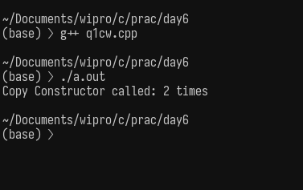

Q.2 Create a class Resource with char* pointer storing a resource name.
Use default copy behavior.
Demonstrate double deletion problem.
Fix it using deep copy.
// Purpose: Demonstrate double deletion using shallow copy
// Date: 29/12/2025
// Author: Vinayak Majhi
// ID: 58618
// Batch ID: 25SUB4505 - DATACOM+5G

#include <cstring>
#include <iostream>

using namespace std;

class Resource {
public:
char *ptr;

Resource(const char *name) {
ptr = new char[strlen(name) + 1];
strcpy(ptr, name);
}

~Resource() { delete[] ptr; }
};

int main() {

Resource r1("Memory");
Resource r2 = r1;

return 0;
}

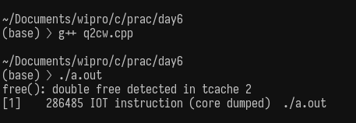
FIX using deep copy
// Purpose: Demonstrate double deletion using shallow copy
// Date: 29/12/2025
// Author: Vinayak Majhi
// ID: 58618
// Batch ID: 25SUB4505 - DATACOM+5G

#include <cstring>
#include <iostream>

using namespace std;

class Resource {
char *ptr;

public:
Resource(const char *name) {
ptr = new char[strlen(name) + 1];
strcpy(ptr, name);
}

Resource(const Resource &obj) {
ptr = new char[strlen(obj.ptr) + 1];
strcpy(ptr, obj.ptr);
}

~Resource() { delete[] ptr; }
};

int main() {

Resource r1("Network");
Resource r2 = r1;

return 0;
}

Assignment
(Notepad)

Q.1. Problem #1:
-----------
Implement a class MyString so that,
1. It represents an array of characters which is allocated dynamically
2. Perform deep copy by defining default, single parameterized and copy constructor. Also provide destructor.
Data members:
char *data;//stores null terminated string
unsigned int len;//stores the length
Functions:
default constructor // creates an empty string
single parameterized ctor // allocate memory an store the string.
copy constructor // Deep copy
Destructor
unsigned int size()const; //returns length
const char *cStr()const; //returns data
void disp() const; //prints length and data

// Purpose: Custom MyString class with deep copy
// Date: 29/12/2025
// Author: Vinayak Majhi
// ID: 58618
// Batch ID: 25SUB4505 - DATACOM+5G

#include <cstring>
#include <iostream>

using namespace std;

class MyString {
char *data;
unsigned int len;

public:
MyString() {
len = 0;
data = new char[1];
data[0] = '\0';
}

MyString(const char *str) {
len = strlen(str);
data = new char[len + 1];
strcpy(data, str);
}

MyString(const MyString &obj) {
len = obj.len;
data = new char[len + 1];
strcpy(data, obj.data);
}

~MyString() { delete[] data; }

unsigned int size() const { return len; }

const char *cStr() const { return data; }

void disp() const {
cout << "Length: " << len << endl;
cout << "Data: " << data << endl;
}
};

int main() {

MyString s1("Resource");
MyString s2 = s1;

s1.disp();
s2.disp();

return 0;
}

